Hyoungjun Lee  
2/21/20  
Computer Org&Programming  
Project A2, Task 4

Task 4, ARM assembler in Raspberry PI

1. Part1, Second Program

Here is program to represent c = a + b, written code is below

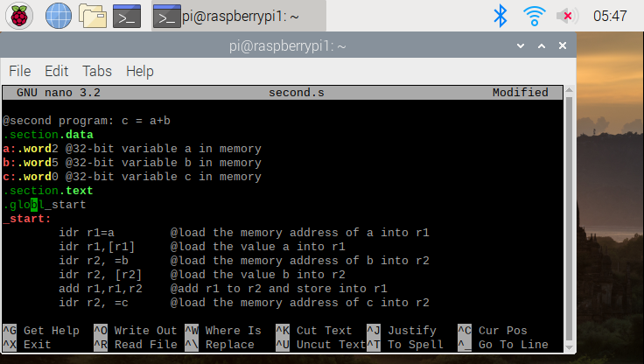

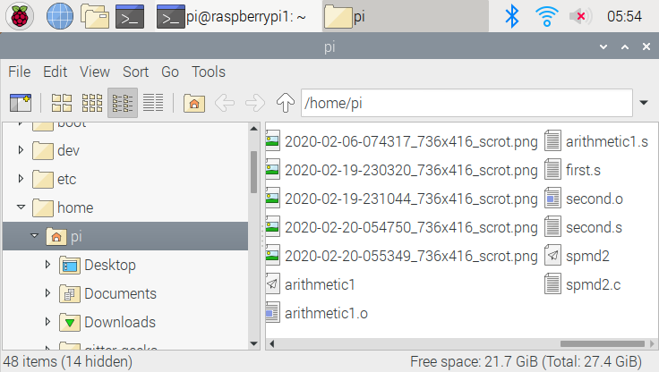

I assembled file first, and create second.o file, and link this file to executable, but there was no output we can find, all the output should be inside registry that we can’t see it but we can see by debugging

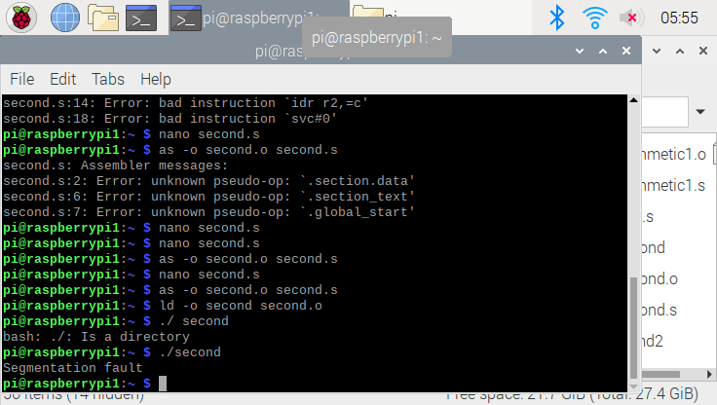

After I see the all the list inside second.o by debugging, to stop debugging, we set break point at b 15, in order to step by step , I used “stepi” command to execute program, as shown in the below

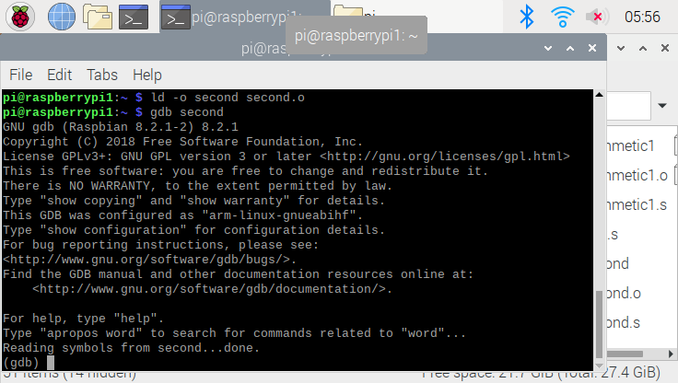

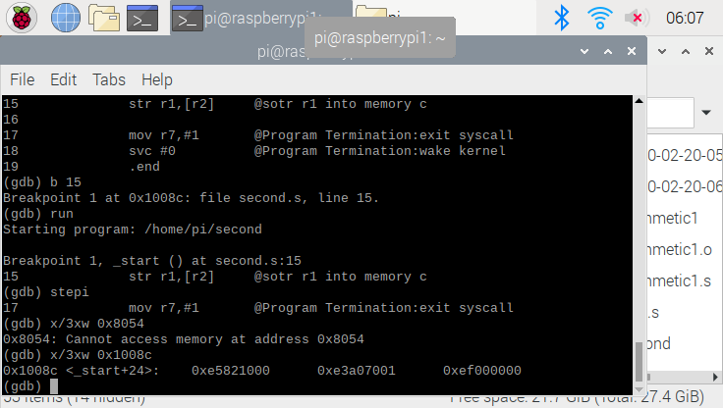

This command x/3xw 0x100990 was used to generate three words in hexadecimal: 0xe5821000, 0xe3a07001, 0xef000000.

Part2)

And here is program to represent Register = val2 +9 +val3 -val1

After write code inside arithmetic2.s, I assembled file and linked it in order to receive an executable file, but also, same as part 1, I could not see any output, because, all the things inside register, and I debug to see output (GDB), picture of codes are below

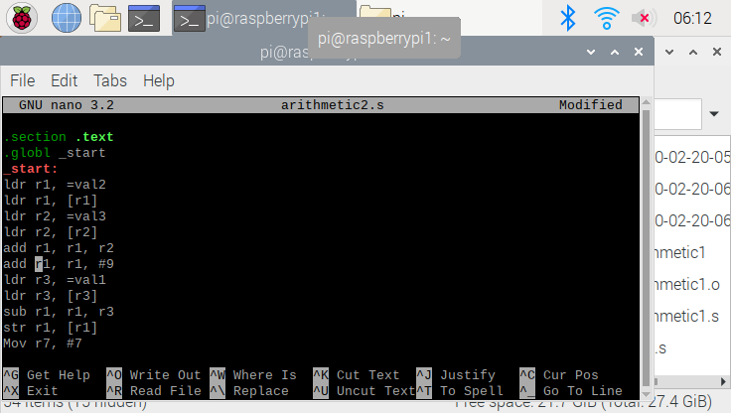

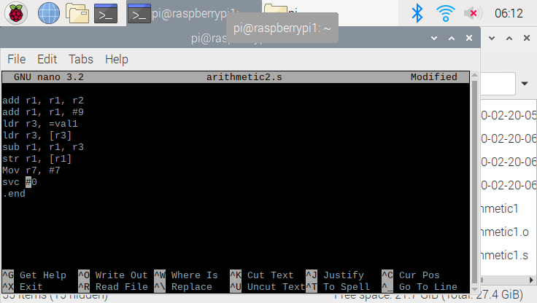

As I did in part 1, I set the break point to see how program work through, to stop debugging I set break point at “b 19” to make sure, I used “info register” to check value of register and compare to the result.  
to execute step by step, I used “ stepi” command to help this out. Pictures are below

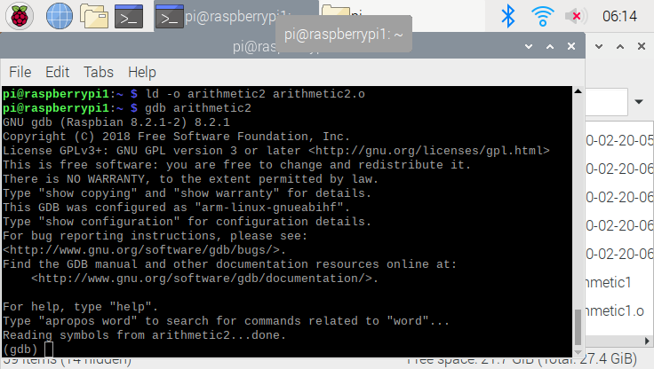

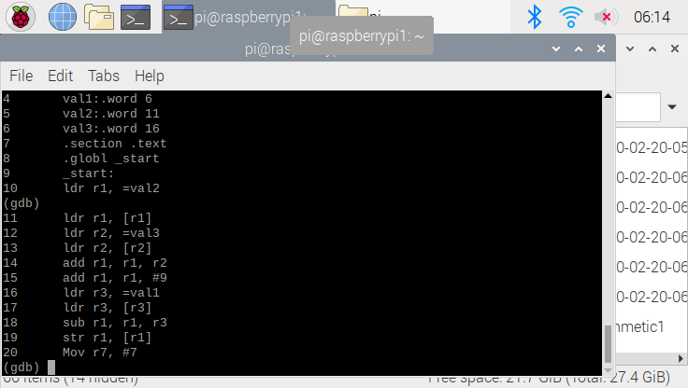

This command x/3xw 0x10098 was used to generate three words in hexadecimal: 0xe5811000, 0xe3a07001, 0xef000000 below picture

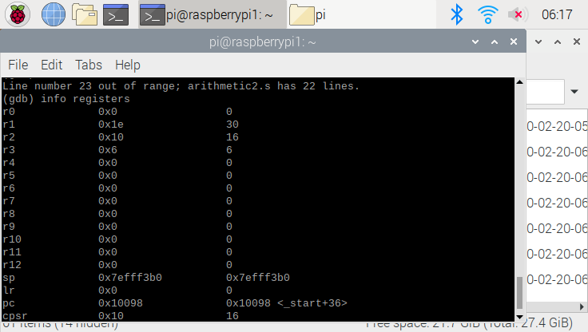

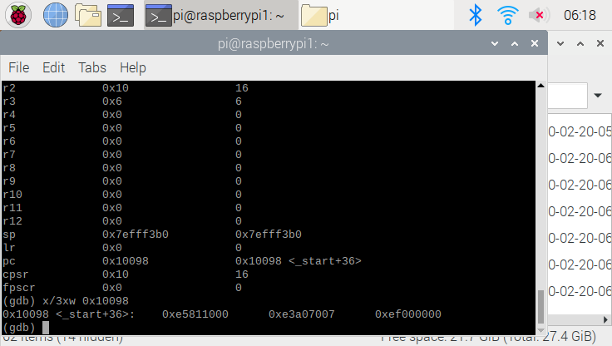

As the result, we can check that register 1 value is same as our equation, Register = val2, +9 +val3 – val1

Which is 30, register 1 through 3, have same value which I declare value inside .data section.